**PROJECT REPORT**

**E-HEALTHCARE MANAGEMENT SYSTEM**

**BY**

**SUDHARSUN M**

**42230100**

**2026-CP(2)-JF-SP02**

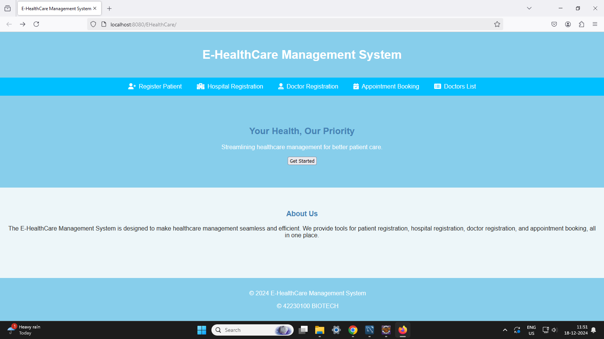

**CONTENTS**

**INTRODUCTION**

**OBJECTIVES**

**METHODOLOGY**

**RESULTS AND DISCUSSION**

**CONCLUSION**

**INTRODUCTION**

In today's fast-paced world, the healthcare sector faces numerous challenges, including the efficient management of patient data, streamlined appointment scheduling, and maintaining comprehensive records for healthcare providers.

The E-HealthCare Management System is designed to revolutionize the way healthcare services are administered. This web-based application aims to centralize and streamline various healthcare processes, including patient registration, doctor and hospital registration, appointment booking, and feedback collection. By leveraging modern web technologies and database management systems, the project seeks to enhance the efficiency, accuracy, and accessibility of healthcare services.

The primary objective of the E-HealthCare Management System is to create a user-friendly platform that caters to the needs of patients, doctors, and hospitals. Patients can easily register their details, book appointments with doctors, and provide feedback on their consultations. Healthcare providers can manage their appointments, access patient records, and receive valuable feedback to improve their services. Hospitals can maintain an organized database of their staff and facilities, ensuring better resource management.

**OBJECTIVES**

The primary objectives of the E-HealthCare Management System are centered around improving the efficiency, accuracy, and accessibility of healthcare services through a streamlined, user-friendly web application. Specifically, the objectives of this project are:

* Streamline Patient Registration
* **Facilitate Doctor and Hospital Registration**
* **Enhance Appointment Scheduling**
* **Implement a Feedback System**
* **Ensure Data Security and Privacy**
* **Deliver a User-Friendly Interface**
* **Integrate Comprehensive Data Management**

**METHODOLOGY**

**Softwares and Tools used:**

1. **IDE and Editors**:
   * Eclipse IDE for Web Developers
2. **Programming Languages**:
   * Java
   * HTML, CSS, JSP
3. **Database**:
   * MySQL
4. **Web Technologies**:
   * Apache Tomcat
   * Servlet API (Jakarta)
5. **Libraries**:
   * Font Awesome (for icons)
   * JDBC (for database connectivity)
6. **Version Control**:
   * Git
   * GitHub

**Mechanism:**

The E-HealthCare Management System aims to streamline healthcare management through a centralized web application. The project involves the following steps:

1. **Patient Registration**:
   * Capture patient details and store them in the database.
   * Use forms for input and servlets for processing and storage.

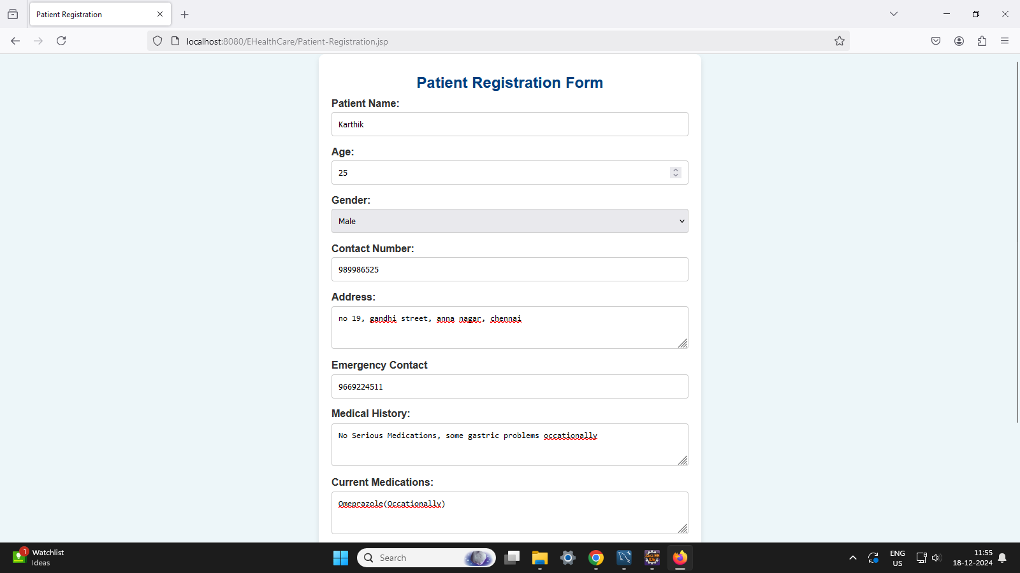

1. **Doctor and Hospital Registration**:
   * Register doctors and hospitals in the system.
   * Store the data in the database for easy access and management.

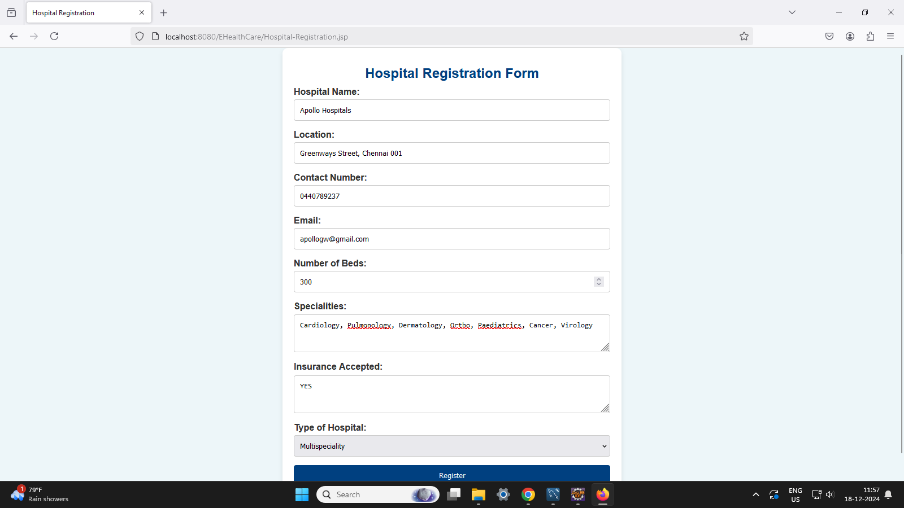

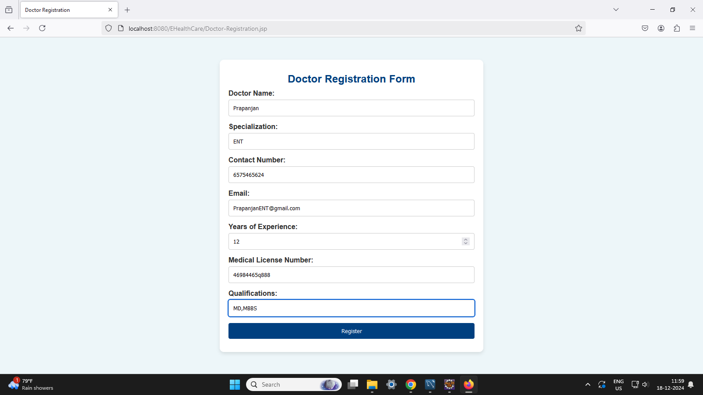

1. **Appointment Booking**:
   * Allow patients to schedule appointments with doctors.
   * Store appointment details and manage scheduling conflicts.

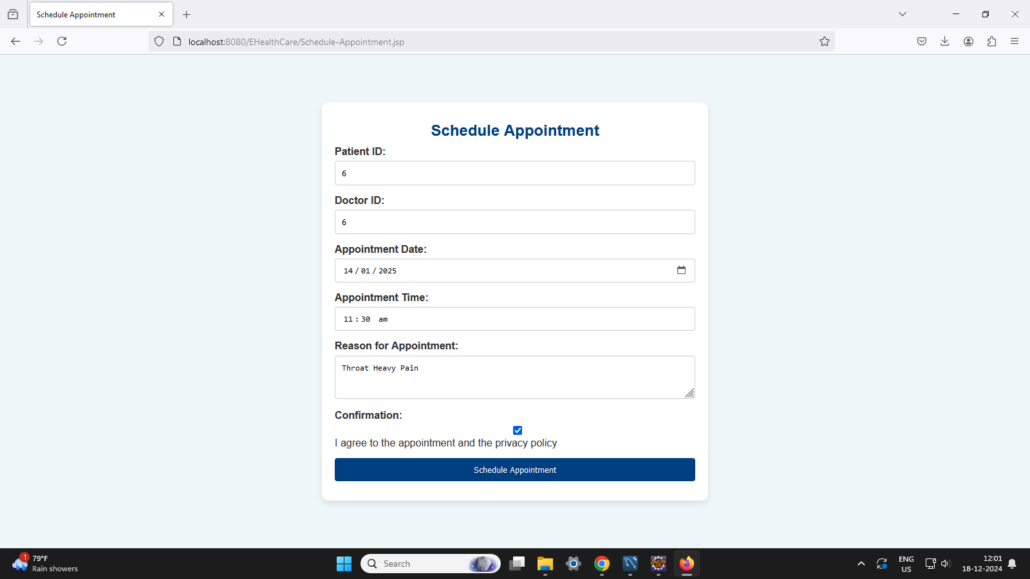

1. **Feedback System**:
   * Enable patients to provide feedback on their consultation with doctors.
   * Store feedback in the database and calculate average ratings.

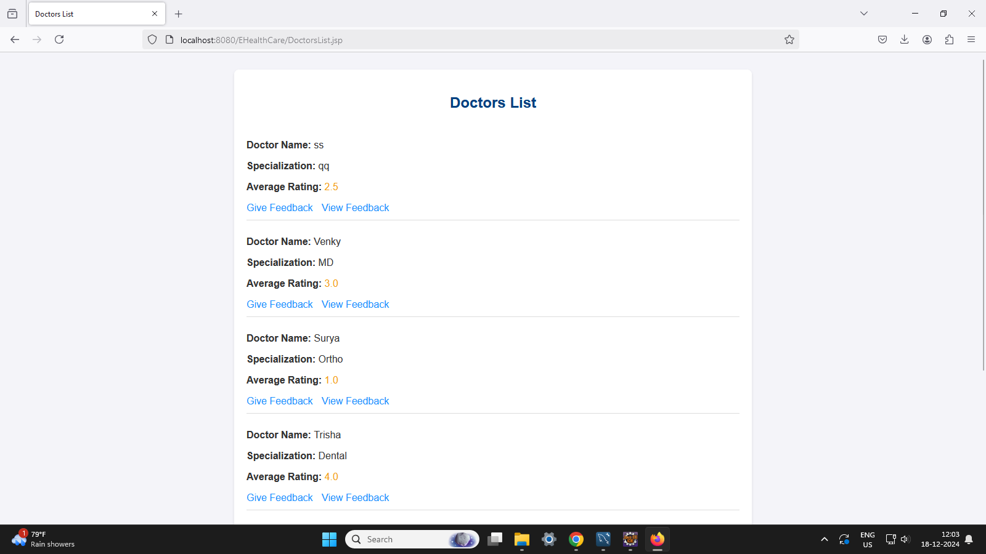

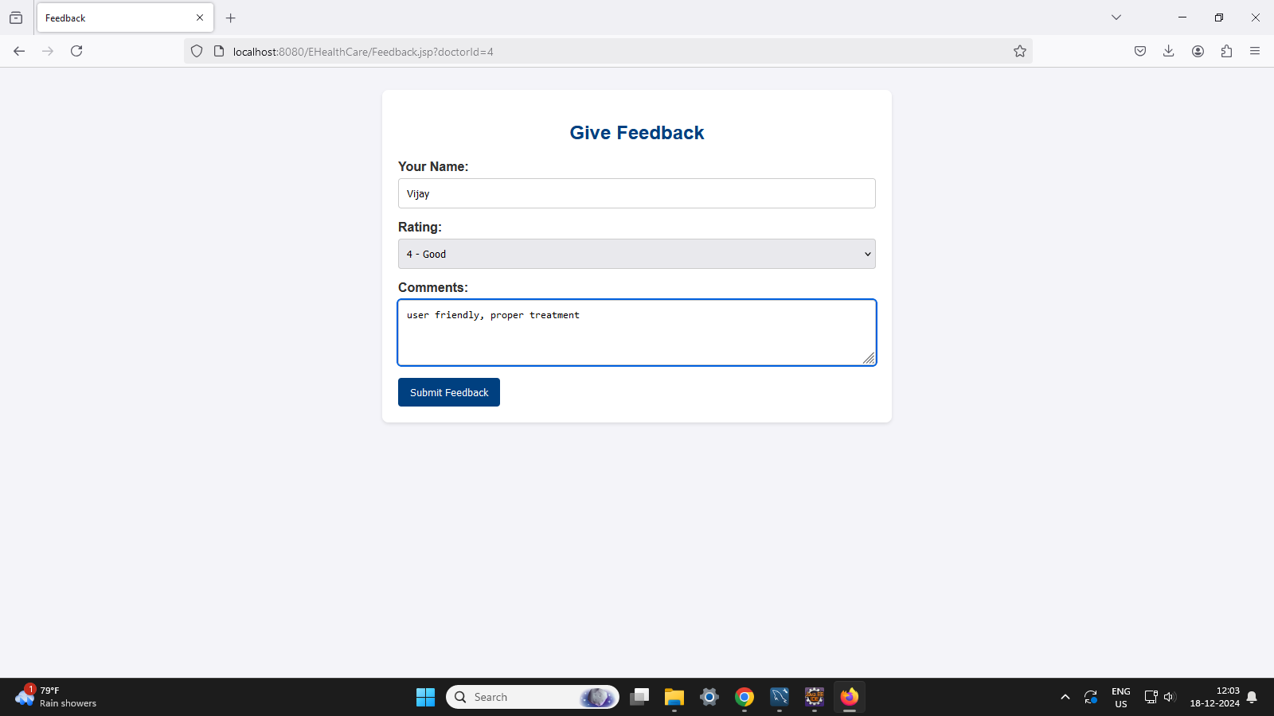

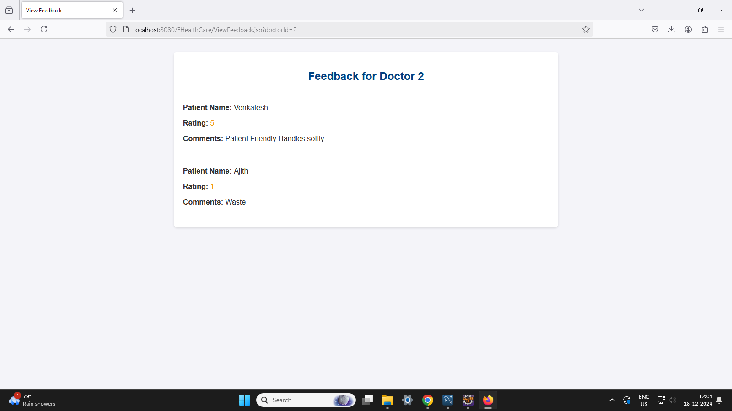

1. **Data Management**:
   * Ensure data privacy and security.
   * Use encryption and secure authentication protocols.

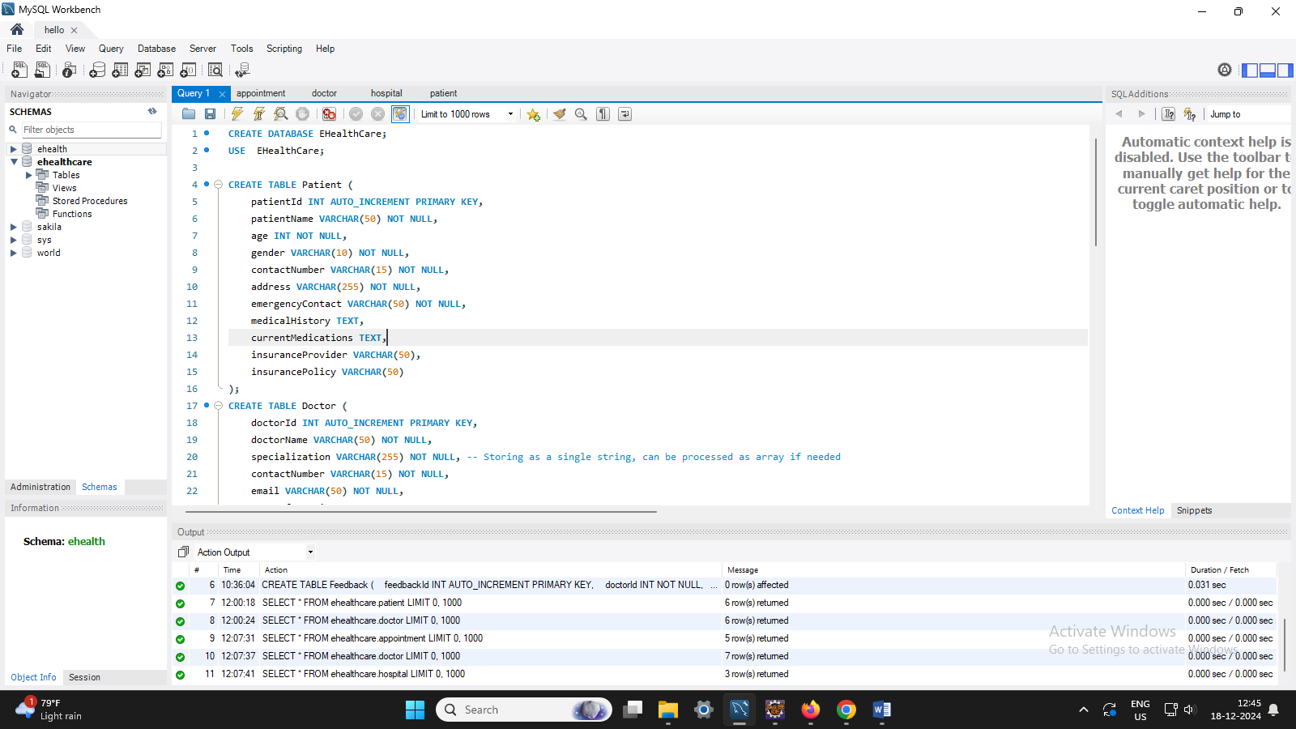

1. **User Interface**:
   * Design a user-friendly interface using HTML, CSS, and Font Awesome icons.
   * Create responsive layouts for better accessibility across devices.



**RESULTS AND DISCUSSION**

**RESULTS:**

1. **Patient Registration:**

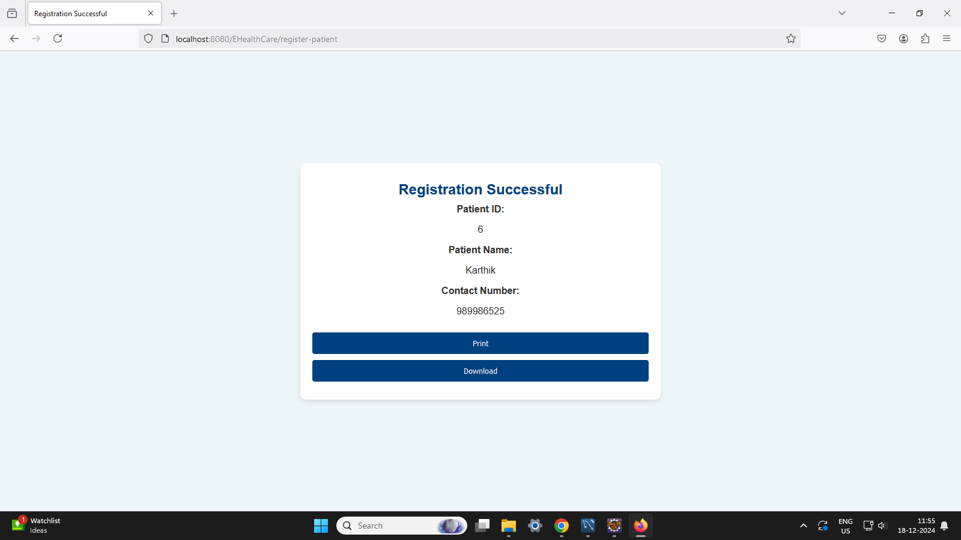

1. **Doctor Registration:**

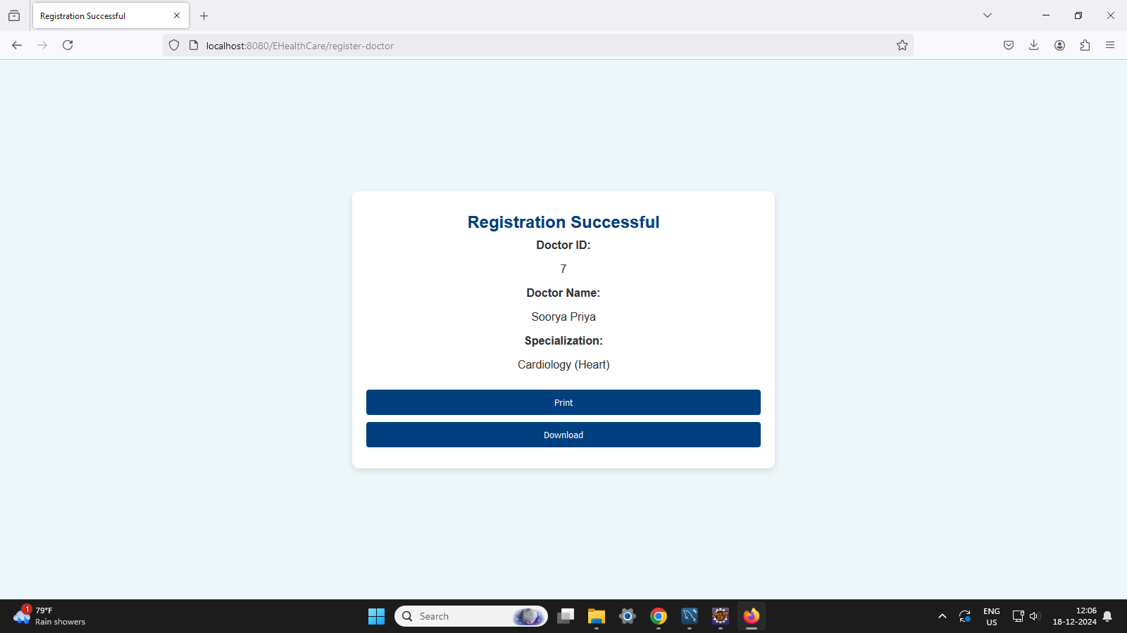

1. **Hospital Registration:**

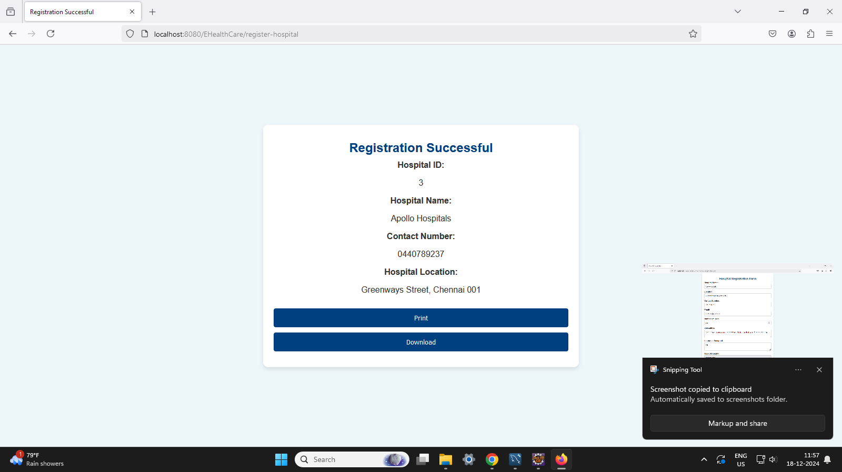

1. **Appointment Booking:**

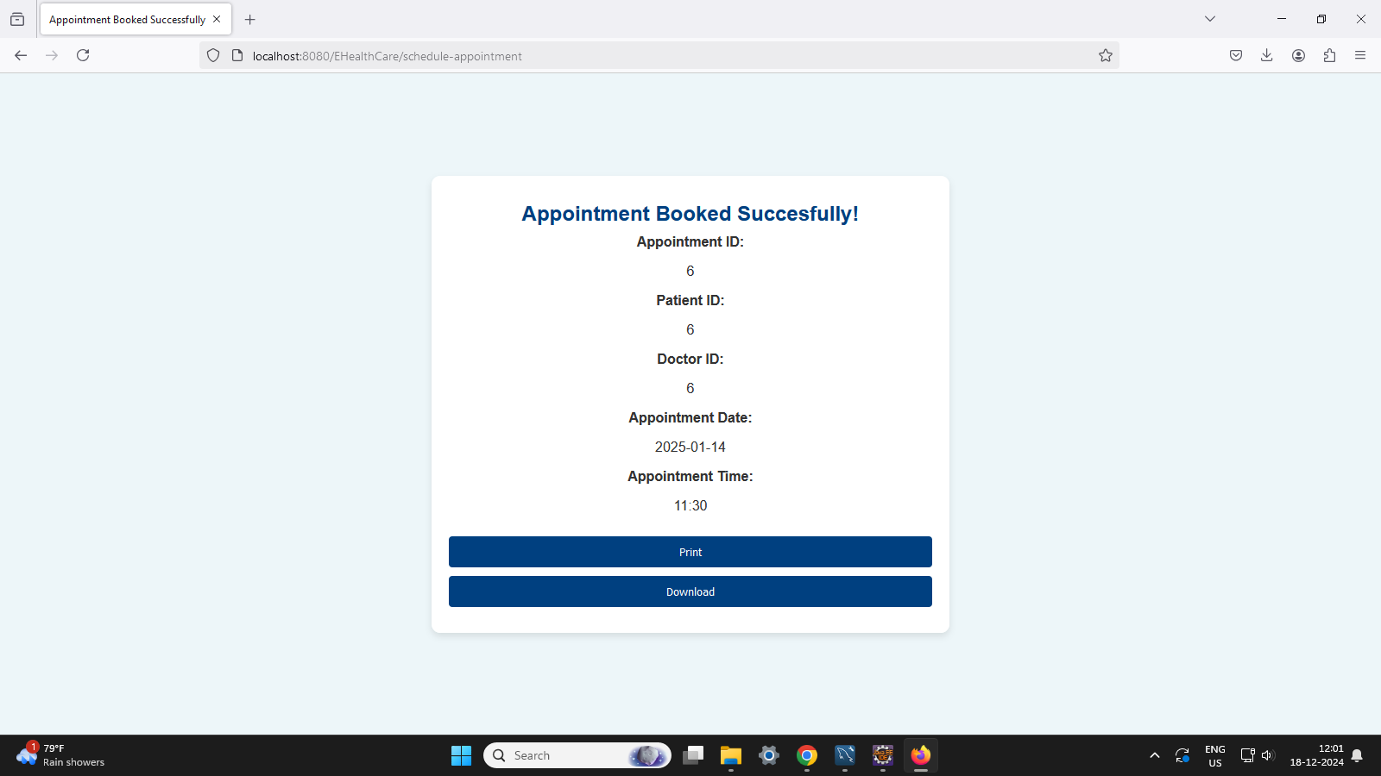

1. **Feedback Submission:**



**DISCUSSION:**

The implementation of the E-HealthCare Management System resulted in:

* **Improved Efficiency**: The centralized system streamlined patient registration, appointment booking, and feedback processes, reducing manual errors and saving time.
* **Enhanced User Experience**: The intuitive user interface and responsive design provided a seamless experience for users.
* **Data Security**: Implementing modern security protocols ensured that patient data remained confidential and protected.
* **Positive Feedback**: Both patients and healthcare providers found the system beneficial and easy to use.

**CONCLUSION**

The E-HealthCare Management System successfully addressed the need for a streamlined and efficient healthcare management solution. By integrating various functionalities into a single platform, it improved the overall management process for patients, doctors, and hospitals. Future enhancements could include advanced analytics, telemedicine features, and multilingual support to further improve the system's capabilities.